Exam 1 Review
- Consider the area bounded by the curve and the x-axis for . Set up, but do not evaluate, integrals for each of the following.

- The volume of the solid obtained when the function is rotated around the line .

- The volume of the solid obtained when the function is rotated around the line .

- The length of the curve.

- The surface area obtained by rotating the curve about the y-axis.

- The surface area obtained by rotating the curve about the x-axis.

- Consider the shaded region that is bounded by the curves and (shown below).
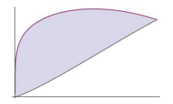
- Setup, but do not evaluate, an integral which represents the area of the region.

- Suppose that the given region is the base of a solid where the cross sections parallel to the y-axis are rectangles which are half as tall as they are wide. Setup, but do not evaluate, an integral which represents the volume of this solid.

- Setup, but do not evaluate, an integral which represents the volume of the solid obtained when the given region is rotated about the x-axis.

- Consider the region bounded by the curves , , and .

- Determine the area of the region by integrating with respect to x.

- Determine the area of the region by integrating with respect to y.

- Setup, but do not evaluate, an integral(s) that represents the volume of the solid obtained when the region is revolved about the line .

(i) Integrate with respect to x.

(ii) Integrate with respect to y.

- A 60m climbing rope is hanging over the side of a tall cliff. How much work is performed in pulling the rope up to the top, where the rope has a mass of g/m?

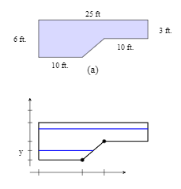
- A rectangular swimming pool is 20ft wide and has a 3ft “shallow end” and a 6ft “deep end”. A full picture of the pool and its dimensions are shown in the diagrams below. Determine the total amount of work needed to pump the water to the top of the pool. (The density of water is )

